Name: _____________________
English 12/Culture & Literature
Identity Map

When we consider characters in books, we often list their character traits according to four categories: physical, emotional, intellectual, and moral. How would you characterize YOURSELF using these traits?

Task: Create an identity map that represents you.

Steps:

1. Put your name at the center of a piece of paper. You can write it out or use your Chromebook.

2. Brainstorm roles and nouns:

- Consider all the roles you identify with in the different facets of your life. You can think of your familial roles (Big brother? Big sister? Baby of the family?); your role in school (Writer? Reader? Scientist? Computer expert? Artist? Class clown?); your role outside of school—at a job, on the Internet, or among friends (Hockey player? Driver? Confidant?); or any other roles that may come to mind, like cultural or religious roles (Chinese-American, Christian, Jew)

- Draw a different line or ray on your identity map for each role you wish to include. At the end of each line, write the word that identifies that particular role.

- Include at least 4 roles/nouns that define you. (See rubric for scoring)

3. Incorporate adjectives:

- What adjectives describe you? Brainstorm.

- Adjectives could be written at the end of lines that originate at their names and branch out (if they are adjectives that generally apply to their identities), or they could be rays surrounding a particular role (e.g., the adjective "responsible" might be used to describe "big sister," or "competitive" may be used to describe "gamer").

- Use strong words to describe yourself-- not vague, trite or commonplace adjectives. For example, if you are thinking of the word "nice," what word could you use to be more descriptive? (Sympathetic? Tolerant? Charitable?)

- You must include at least 5 adjectives in your identity map. (See rubric for scoring)

4. “Decorate” or illustrate your map in any way you see fit.
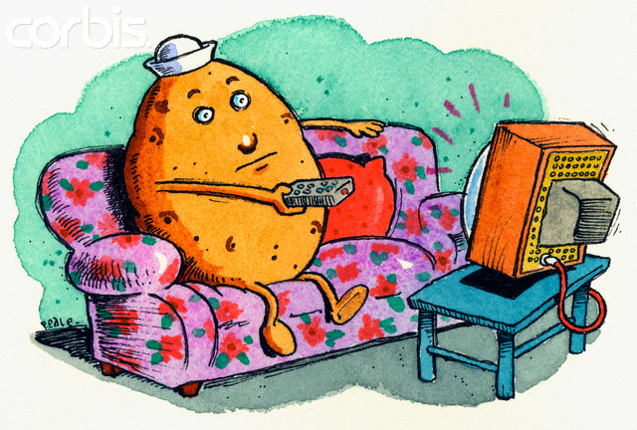

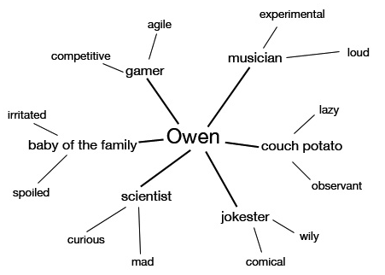
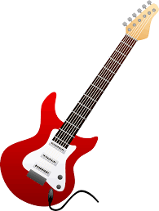

Identity Map Rubric
This is worth three homework assignments or 12 points.
 | Excellent  4 | Good  3 | Fair  2 | Poor  1
Content | Thoughtful and thorough; Contains 6 or more nouns and 10 or more adjectives | Shows effort; Contains 5 or more nouns and 7 or more adjectives | Meets assignment criteria on a basic level: 4 nouns, 5 adjectives, but not much more than that | Does not meet assignment criteria; minimal effort shown
Word Choice | Strong and effective word choice that clearly illustrates the writer | Effective or mostly effective word choice that illustrates the writer | Basic word choice that shows limited thought but completes the assignment | Poor word choice; not enough words to meet assignment criteria
Illustration | Creative and thoughtfully illustrated; graphics illuminate ideas; may include original art | Shows use of illustration to reflect ideas | Minimally illustrated | Not illustrated, or uses inappropriate illustrations

