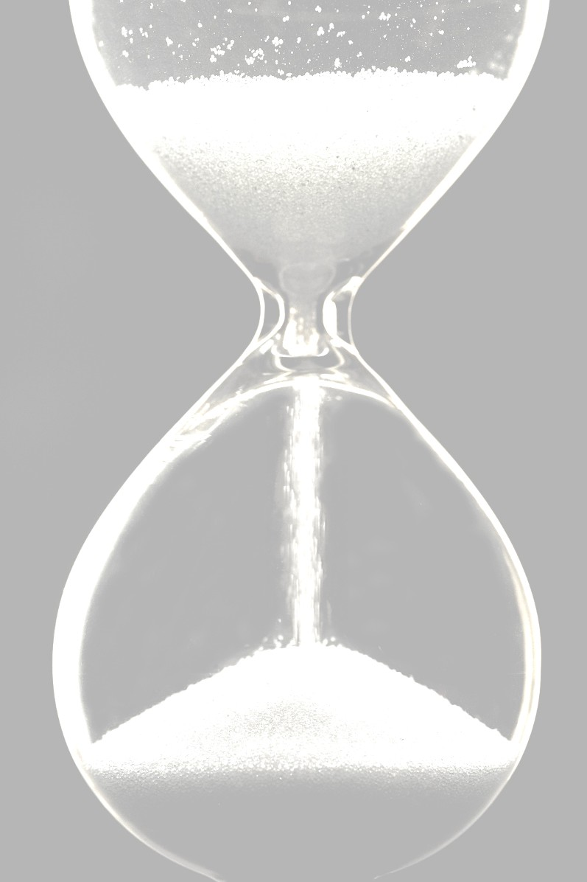
"We throw our parties; we abandon our families to live alone in Canada; we struggle to write books that do not change the world, despite our gifts and our unstinting efforts, our most extravagant hopes. We live our lives, do whatever we do, and then we sleep. It’s as simple and ordinary as that. A few jump out windows, or drown themselves, or take pills; more die by accident; and most of us are slowly devoured by some disease, or, if we’re very fortunate, by time itself. There’s just this for consolation: an hour here or there when our lives seem, against all odds and expectations, to burst open and give us everything we’ve ever imagined, though everyone but children (and perhaps even they) know these hours will inevitably be followed by others, far darker and more difficult. Still, we cherish the city, the morning; we hope, more than anything, for more."

-Michael Cunningham, The Hours

Selected by Ms. McMane: This passage gives me chills. It's about being hopeful in times of trouble, and about the human desire to achieve success and live happy lives despite the inevitable problems of life.

[TYPED PASSAGE in whatever font you choose, but made large enough to fill the page.]

--[AUTHOR], [SOURCE]

Selected by [YOUR NAME], CLASS OF [____]: [Brief description of why you like it or what it means to you.]

(include visual if you desire)

