Student:______________________________________ Home Phone Number:_____________________________________
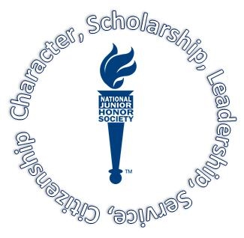
Homeroom Teacher:_______________________________________
National Junior Honor Society
Community Service Hours: Time Sheet
(Minimum requirement of 20 hours)

As per NJHS BYLAWS:
The 20 hours of school/community service must fall between the months of September and May of this school year. Community service hours logged for the NJHS may not be used for any other organization. There are two deadlines for completion of the required 20 service hours:
- The first 10 hours need to be completed on or before January 31st
- The final 10 hours need to be completed on or before May 1st
Failure to complete the required service hours by the deadlines could result in the removal of the member from the National Junior Honor Society (subject to review and hearing by the Faculty Council). All community service work must be pre-approved by the advisors. Failure to do so could result in forfeiture of those hours.

Community service hours for the National Junior Honor Society must be exclusive to this organization (the same community service hours may not be credited to any other organization or purpose).
Generally when choosing service hours, it is best to avoid activities that directly benefit a member’s family.
Service projects done for financial gain or other compensation are not acceptable (i.e.: babysitting).
Suggestions for possible community service hours:
Peer tutoring, Meet the Teacher Night, hospital aide work, volunteer for a community hotline, volunteer work at the library, daycare youth worker, volunteer at an animal shelter or veterinarian office, ambulance/fire department, charitable walks/runs, blood drives, etc.

Name:_________________________________________________
Date | Activity | Advisor’s Approval | Amount of Time | Supervisor’s Signature or Attached Letter

Total Number of Hours________________ Date__________________________________

Number of Hours Still to be Completed ______________/20

