La galette des rois

Ingredients:
1/4 cup almond paste/ cocoa powder  1/4 cup white sugar  3 tablespoons unsalted butter, softened  1 egg  1/4 teaspoon vanilla extract  1/4 teaspoon almond extract  2 tablespoons all-purpose flour | 1 pinch salt  1 (17.25 ounce) package frozen puff  pastry, thawed  1 egg, beaten

Directions:
1. | Place the almond paste into a food processor or blender with about half of the sugar, and process until well blended. Add the butter and remaining sugar and process until smooth. Then blend in 1 egg, vanilla extract, almond extract, flour and salt. Set aside.
2. | Preheat the oven to 425 degrees F (220 degrees C). Butter a baking sheet or line with parchment paper, and set aside.
3. | Roll out one sheet of the puff pastry into an 11-inch square. Keep the pastry cool, do not knead or stretch. Use a large pie plate, cake pan or frying pan to trace an 11 inch circle onto the dough using the tip of a small knife. Place the circle of pastry onto the prepared baking sheet. Repeat with the second sheet of pastry. Refrigerate both sheets.  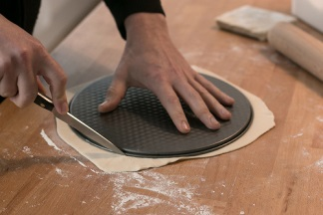
4. | Mound the almond filling onto the center of the pastry that is on the baking sheet. Leave about 1 1/2 inch margin at the edges. Place the second sheet of pastry on top, and press down the edges to seal. Beat the remaining egg with a fork, and lightly brush onto the top of the galette. Use a knife to make a crisscross pattern in the egg wash, and then prick several small slits in the top to vent steam while baking.  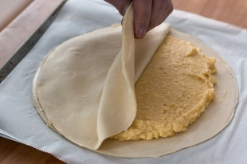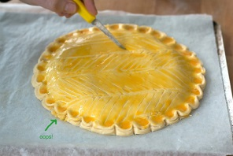
5. | Bake for 30 minutes or until the top is a deep golden brown. Do not open the oven until the time is up, as the pastry will not fully puff. Transfer to a wire rack to cool.
6. | Lay a golden paper crown gently on top of the cake. This will be used to crown the king/ queen!

