The Origami Challenge

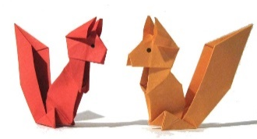
First and Last Name: _______________________________________________________________
Grade: _________
Classroom Teacher: ______________________________________
Origami Animal: __________________________________________
List three interesting facts about your animal:
- _____________________________________________________________________________
- _____________________________________________________________________________
- _____________________________________________________________________________
All entries are due Tuesday, November 19th!

The Origami Challenge

First and Last Name: _______________________________________________________________
Grade: _________
Classroom Teacher: ______________________________________
Origami Animal: __________________________________________
List three interesting facts about your animal:
- _____________________________________________________________________________
- _____________________________________________________________________________
- _____________________________________________________________________________
All entries are due Tuesday, November 19th!

