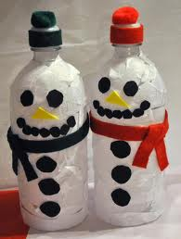
Snow Person Challenge
Name:_______________________
Grade: ________
Teacher: _______________________
What makes you unique? ___________________________________________
How does this uniqueness help you? _________________________________________________________________________________________________________________________________
Snow Person Challenge
Name:_______________________
Grade: ________
Teacher: _______________________
What makes you unique? ___________________________________________
How does this uniqueness help you? _________________________________________________________________________________________________________________________________

