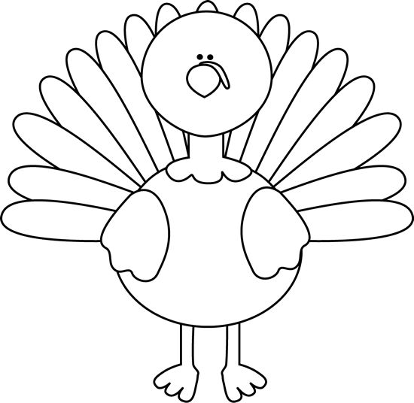

Name: _____________________________
Grade: __________
Teacher: ___________________________

Why is your Turkey’s disguise unique? ____________
___________________________________________
__________________________________________
___________________________________________
__________________________________________
___________________________________________

Name: _____________________________
Grade: __________
Teacher: ___________________________

Why is your Turkey’s disguise unique? ____________
___________________________________________
__________________________________________
___________________________________________
__________________________________________
___________________________________________

