The Tube Challenge

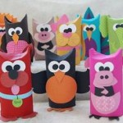
First and Last Name: ____________________________________
Grade: _________
Classroom Teacher: ______________________________________
Animal: _____________________________________________________

Three facts about your animal:

___________________________________________________________________________________

___________________________________________________________________________________

___________________________________________________________________________________
What question do you still have about your animal? __________________________
__________________________________________________________________________________________

The Tube Challenge

First and Last Name: ____________________________________
Grade: _________
Classroom Teacher: ______________________________________
Animal: _____________________________________________________

Three facts about your animal:

___________________________________________________________________________________

___________________________________________________________________________________

___________________________________________________________________________________
What question do you still have about your animal? __________________________
__________________________________________________________________________________________

