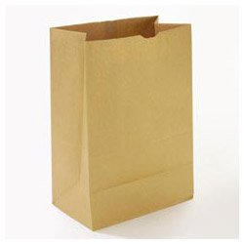
The Paper Bag Challenge
Name:_______________________
Grade: ________
Teacher: ____________________
What did you create? _____________________________
Who is receiving the gift? ____________________________

