Name: ____________________________________ Date: _____________
GT – Advertising Unit Class: _____________
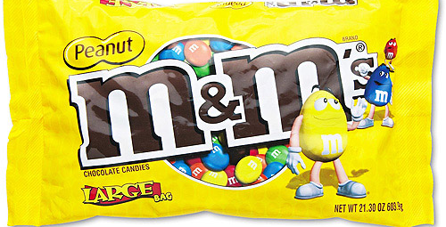
Advertise Yourself
Select a product and advertise yourself as that product. (Examples: soft drink, cereal, bread, soup, salad dressing, candy, chips, shampoo, soap, etc.) They sky is the limit.
Plan ahead!
- Name- Create a name for your product that contains all or part of your name. ______________________________________
- Package – Use the type of package in which the product is normally packages. Cover the original container with an attractive label that represents your personality. Choose your favorite color and design logo to go under the name of the product. My container will be ________________________________
- Slogan – Create a memorable slogan for your product. Include on your packaging and possibly your commercial. ________________________________________________________
- Ingredients – Choose topics that best represent you and your personality traits and talents. (Example: energy, caution, fun, laughter, sweetness, compassion, ambition, etc.)
_______________________________
_______________________________
_______________________________
_______________________________
- Create a QR Code – Write one paragraph “selling” your product. Use advertising techniques to persuade your audience.
____________________________________________________________________________________
____________________________________________________________________________________
____________________________________________________________________________________
____________________________________________________________________________________
____________________________________________________________________________________
____________________________________________________________________________________

- Extra Credit – Create a 30 second commercial for your self-product. It should include a jingle!
Due Date: ____________________________________________________

